**Accessing the Lab:**

1. To access the LODS website the browser should use updated browser version.
2. To access the lab, launch a browser and browse to the URL [**https://trainocate.learnondemand.net**](https://trainocate.learnondemand.net)



1. **Sign in** to the link using the credentials provided by the trainer. After successful login, you will be landing on the Current Training page.

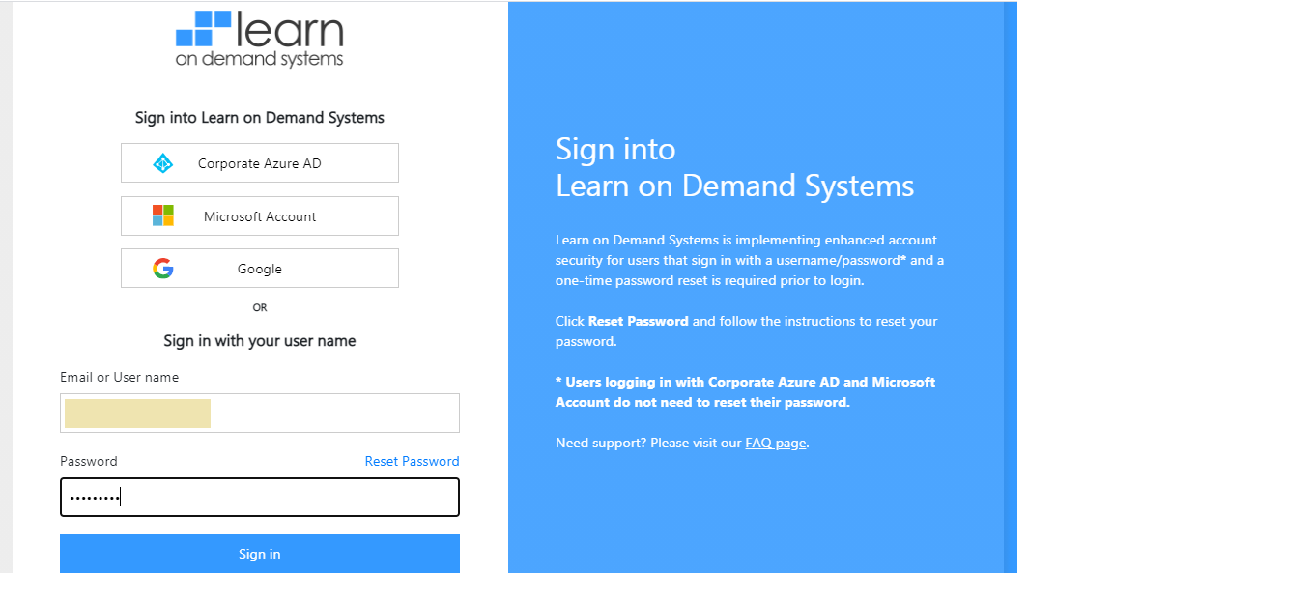

1. From the Course Assignment, ensure the status of the course is in **Not Started** and click on the **ONTAPADM** link.
2. Click **Start** in the next page.

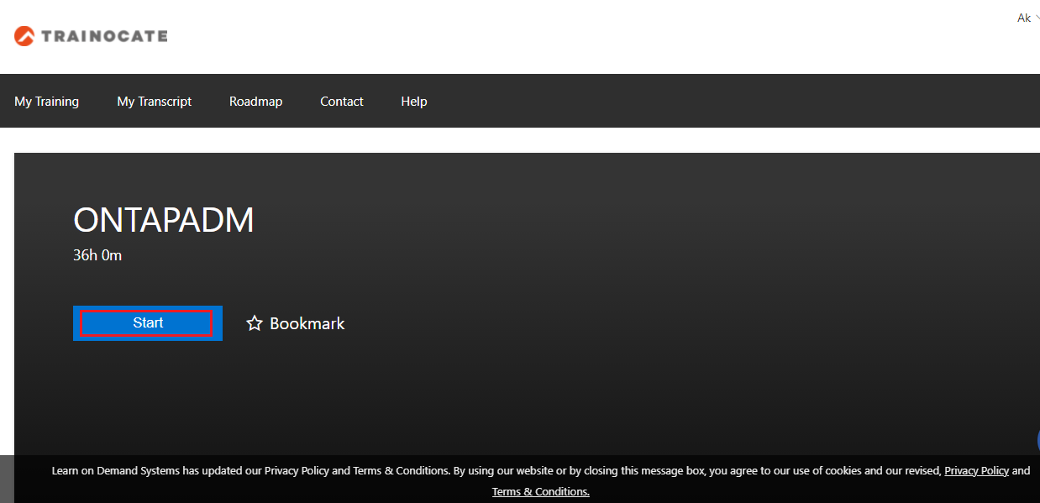

1. Your lab will be launch on a new browser window.

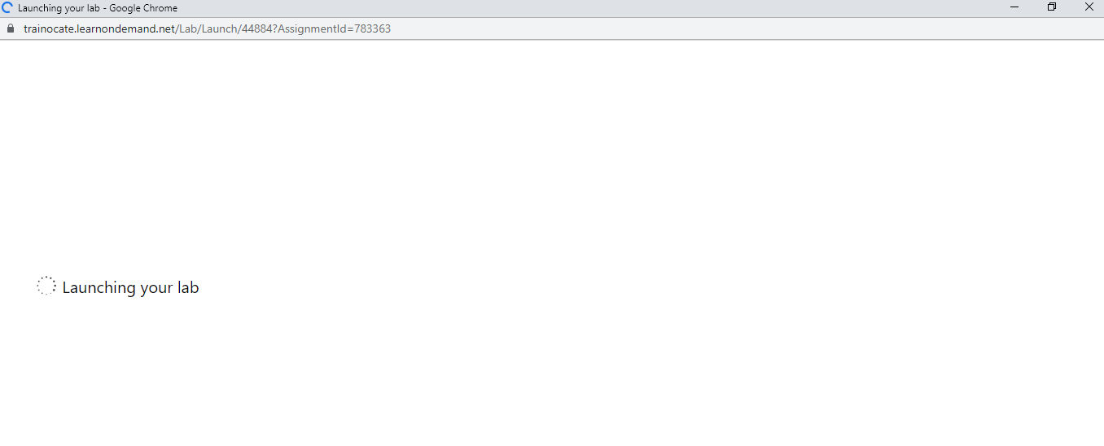

1. Wait for approximately 5 minutes to setup your lab environment.

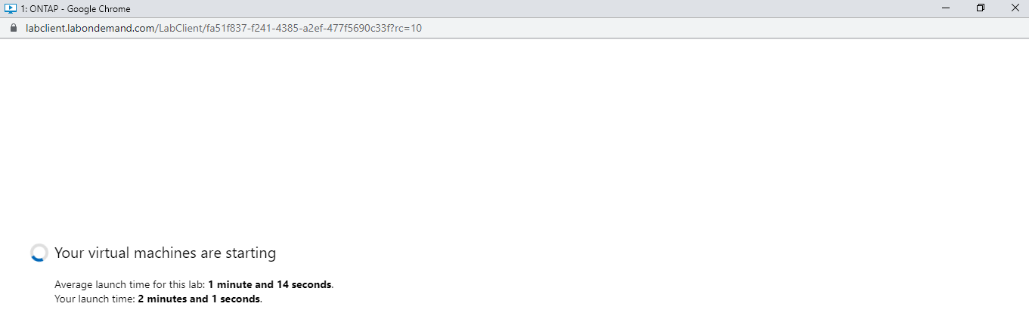

1. After completing the setup, you will be able to access your assigned lab equipment named as **Mgmt PC**.

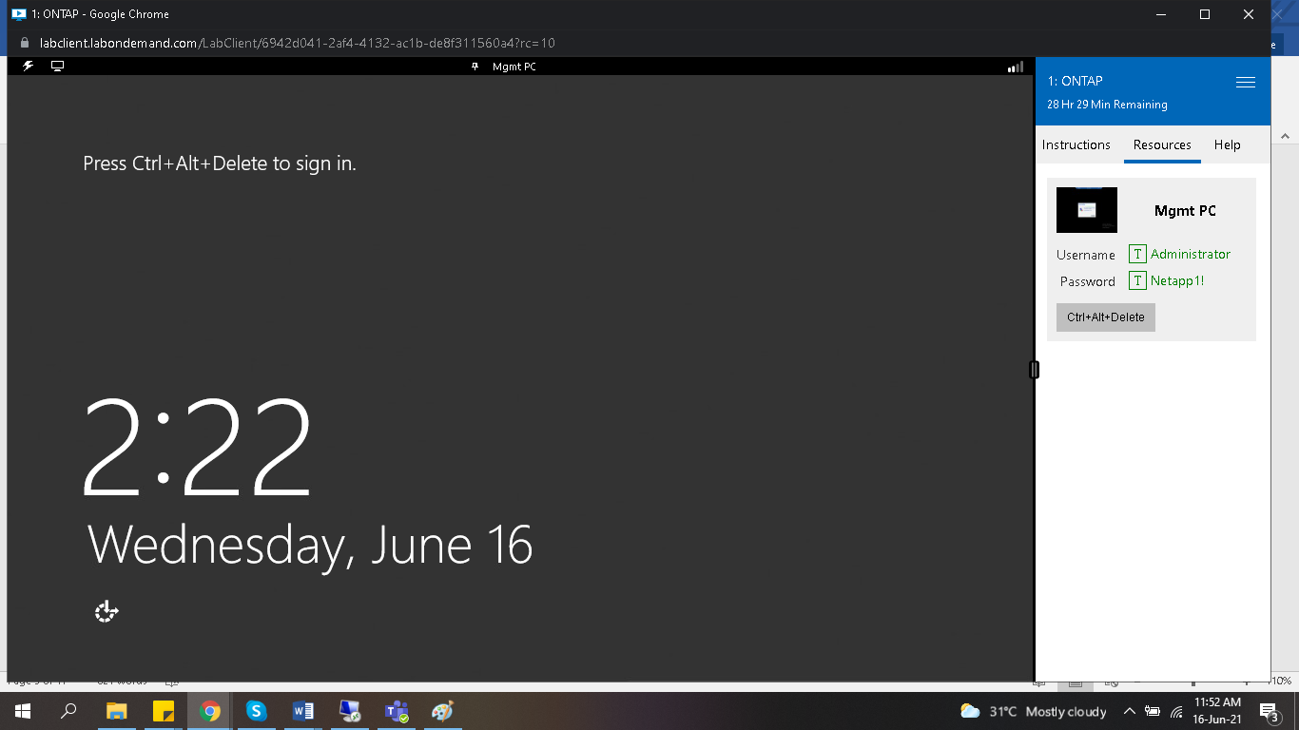

1. From the top left corner, click on **Commands** icon and select **Ctl+Atl+Delete**.

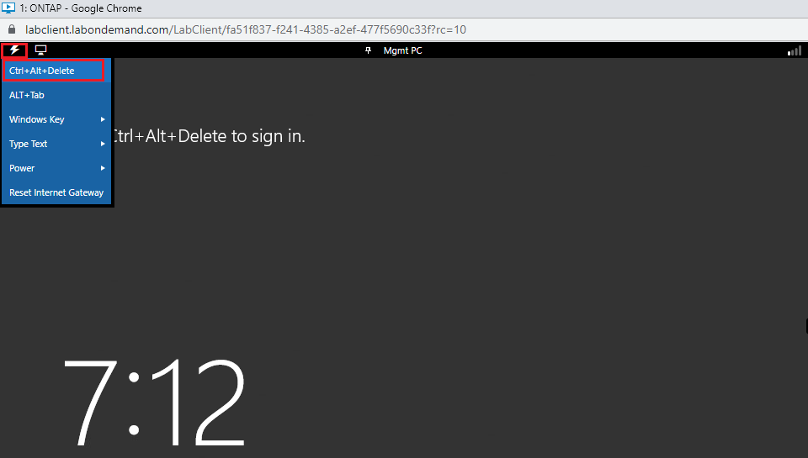

1. Login to the **Mgmt PC** using the credentials **Administrator/Netapp1!.**

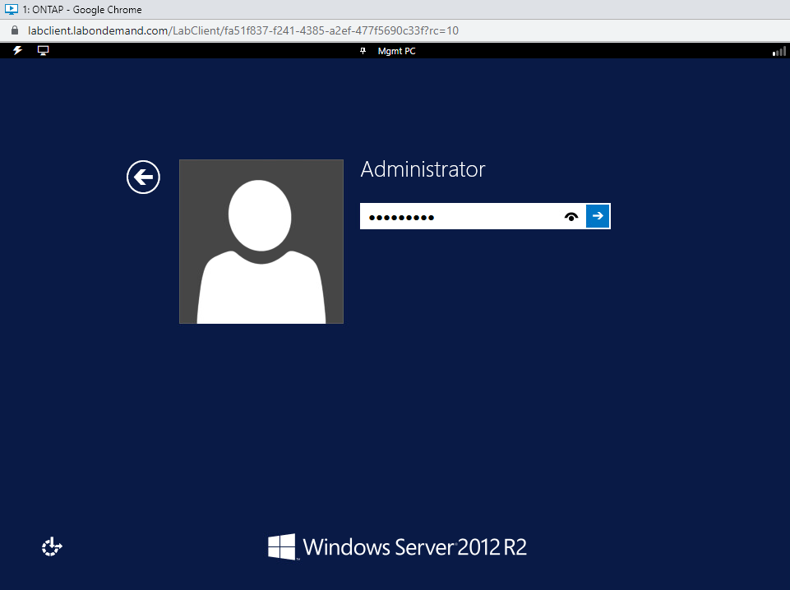

1. You can also view the **Ctl+Alt+Delete** option under **Resource** tab from the right side window.

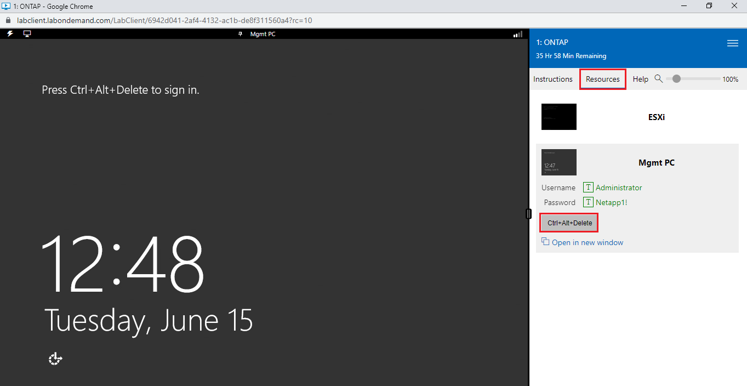

1. Click on the **password field** and from the right side window select the **password**, it will automatically copy the password into the password field.

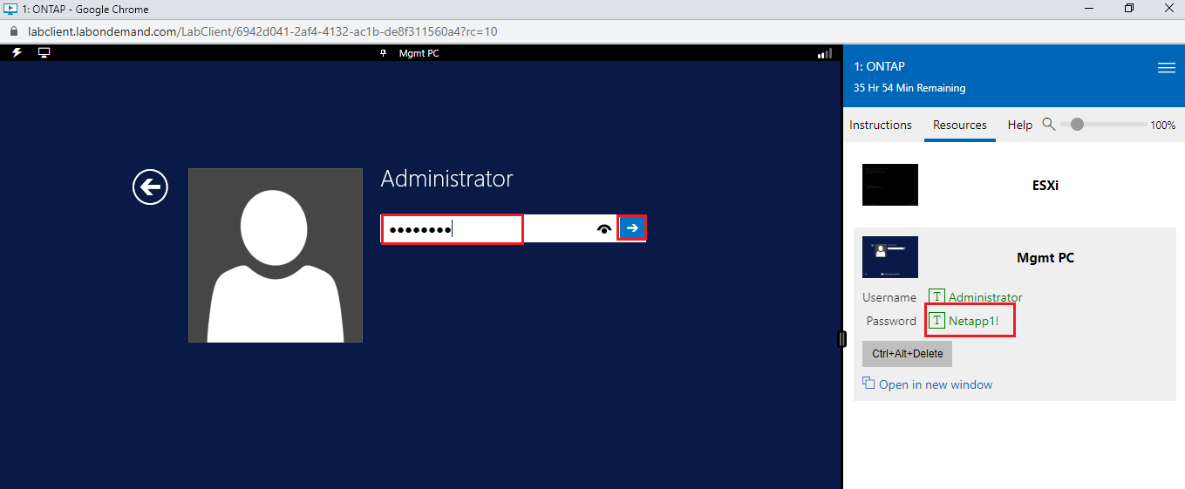

1. Verify that you can see the start page of your assigned windows server 2012 R2.
2. Click **No** to ignore the Network discovery from the Network prompt.

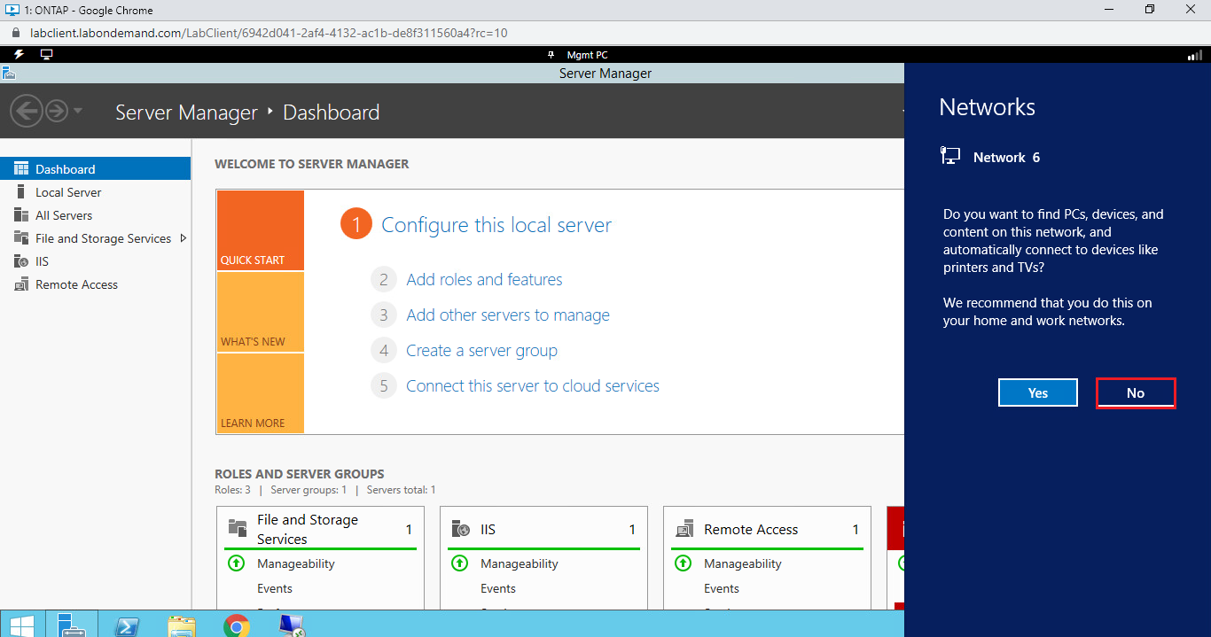

1. **Close** the **Server Manager** window which opened automatically.

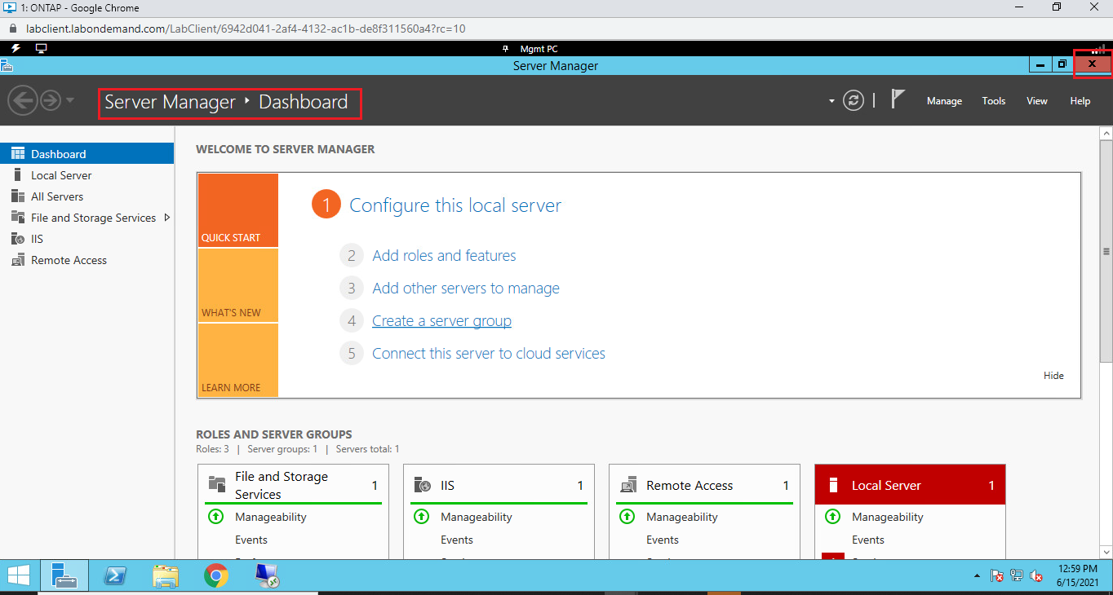

1. If you need to work on full screen view experience, then click on the **Menu** icon in the top right corner and select **Split Windows.**

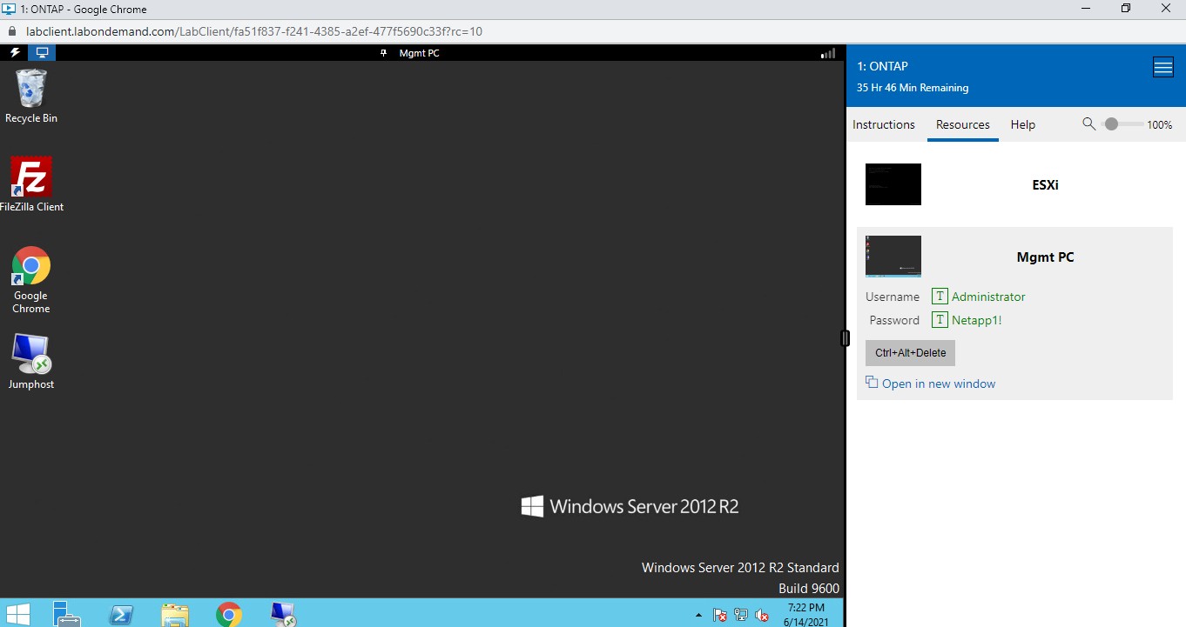

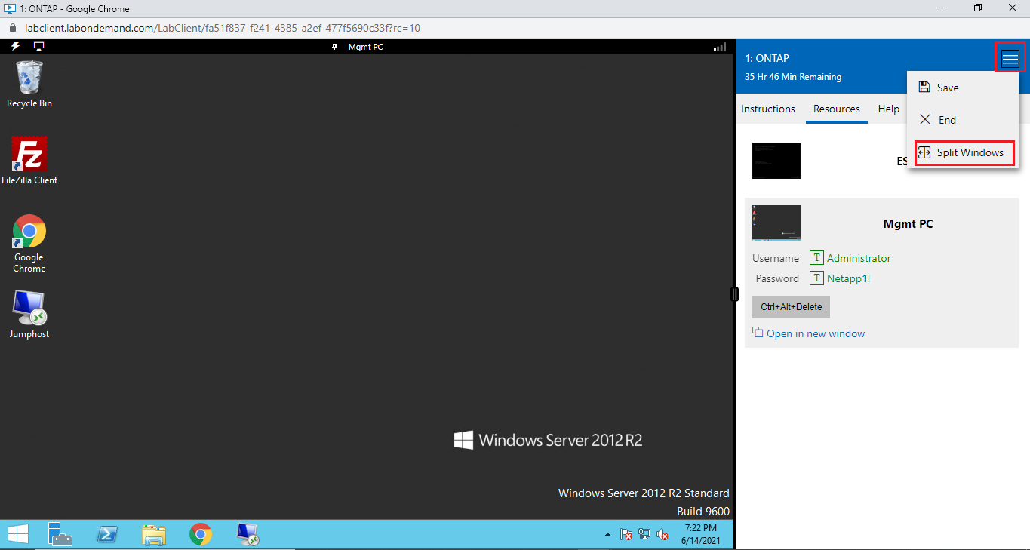

1. You can **Minimize** the Instruction window and start working on windows server 2012 window for better experience.

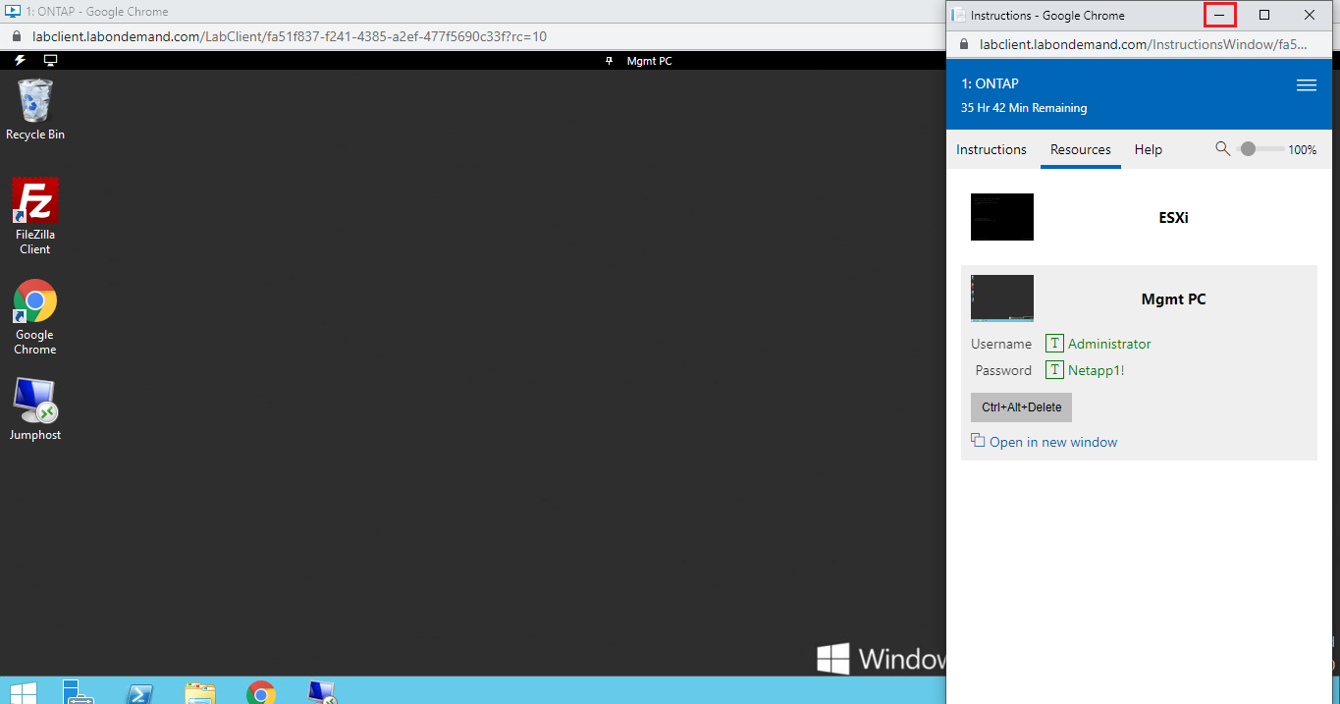

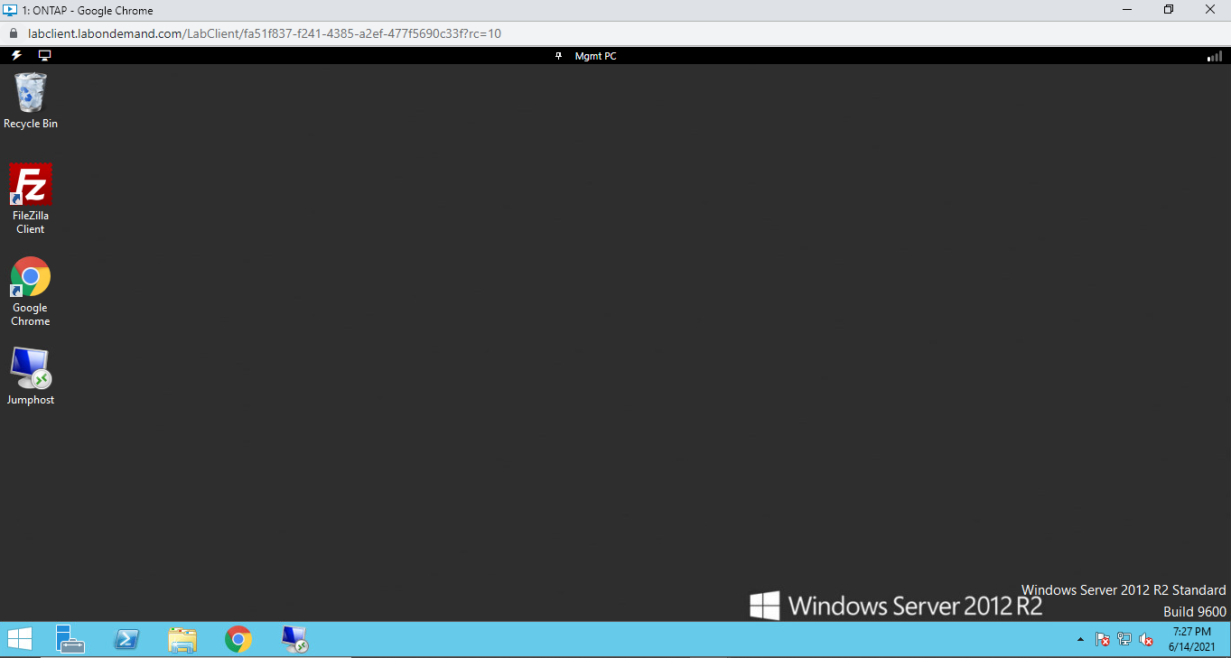

1. It takes approximately 10 minutes for all VM to boot up, so please wait for 10 minutes.
2. After 10 minutes access the **Jumphost** via RDP, from your **Mgmt PC** desktopopen the shortcut of saved RDP session with the name **Jumphost.**

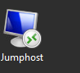

1. In the security page click **Connect.**

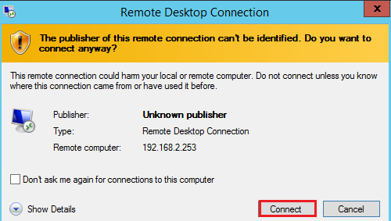

1. In the **Windows Security** box, enter the password as **Netapp1!** and click **OK.**

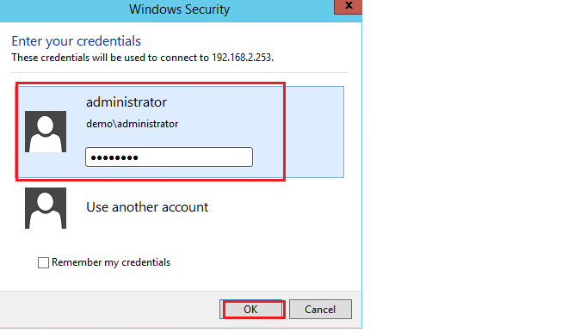

1. Click **Yes** in the certification check prompt.

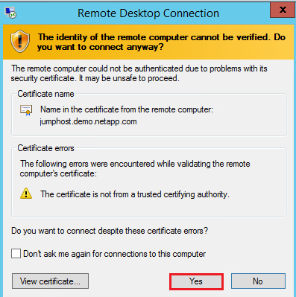

1. Now you can proceed with the labs by using the Jumphost VM.

**Note: When you complete the labs you can click on the Main Menu and select End to end the lab activity. This will terminate the lab and will not save your progress, so make sure to do it only when you want to end the lab.**

1. From the split window if you want to join it back click on the Menu icon and select **Join Window.**
2. Click on **Menu** icon and **Save** the session.

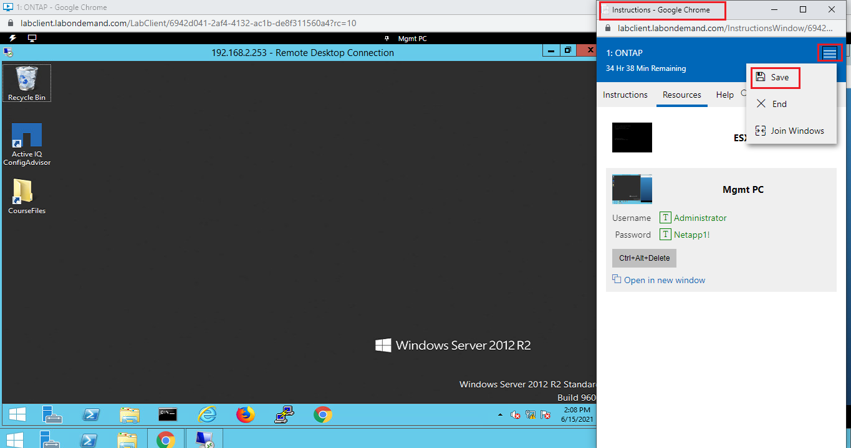

1. Click on **Yes, save my lab.**

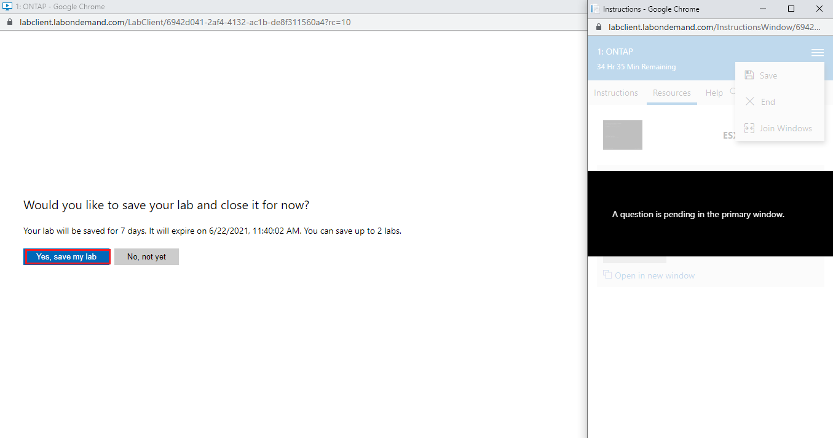

1. Verify that your lab is saved successfully and close the window.

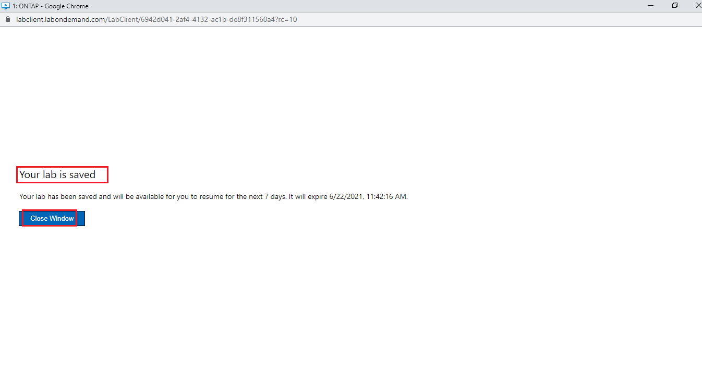

1. From the on demand browser page click on **Continue** to access your lab workspace again.

